Email: ____________________________________

Rev. 7-20

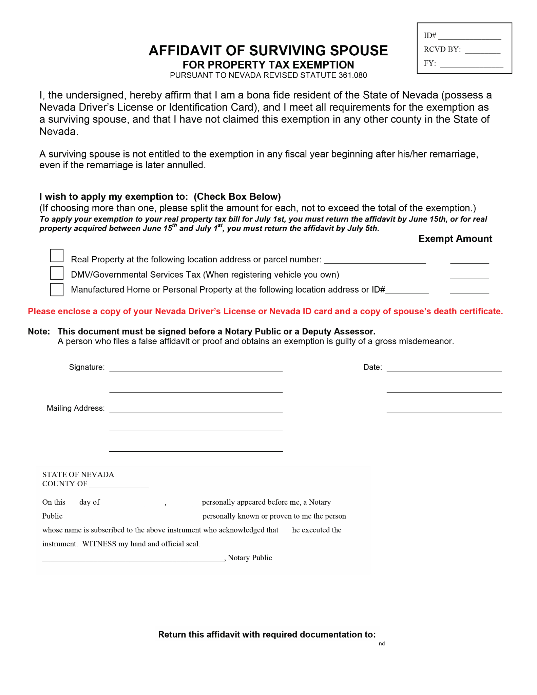

or email to: AOCustomerServiceRequests@ClarkCountyNV.gov